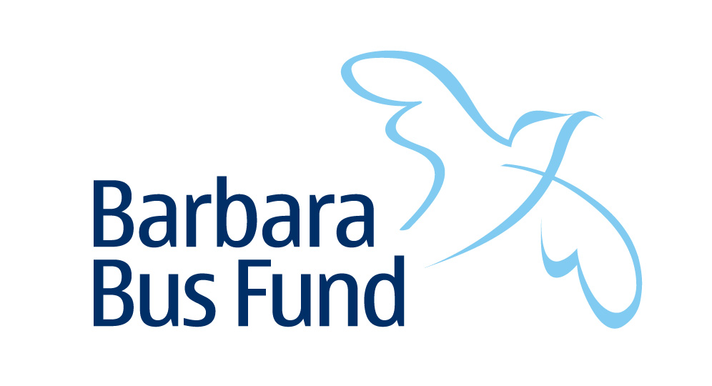
Registered Charity No. 257507

Website: www.barbarabus.com

In Association with SURF ( Spinal Unit Recreation Fund )

Phone: 01924 781492 Email: p.hanley@blueyonder.co.uk

TERMS AND CONDITIONS OF USE

When using the Barbara Bus Fund vehicle you must comply with the following at all times:

- Check condition of vehicle before use and report any shortcomings without delay
- Use seatbelts and wheelchair clamps as demonstrated at all times when vehicle is in motion
- Complete Drivers’ Log in vehicle
- Return vehicle with full tank of diesel, in a clean condition, at the time stated when booking
- Return keys to the Yorkshire Regional Spinal Injuries Centre, Pinderfields Hospital, Wakefield.
- Report any accident or breakdown to the Fund Co-ordinator Peter Hanley without delay
- Do not permit anyone else to drive the vehicle unless they are also registered with the Fund
- Please Note: Even if the passenger is able to transfer, when using the Barbara Bus vehicle they should always travel in their wheelchair, to meet our insurance and the Charity Constitution requirements.

Information for Barbara Bus Drivers.

Please keep for reference when using the Citroen Dispatch vehicle,

Registration Number: LT 58 NNB

Where to find the vehicle

Our vehicle is kept at Stanley Hall, Aberford Road, Wakefield.
Entrance is off the roundabout at the junction of Bar Lane & Aberford Road. You will be shown the location when you attend for a vehicle demonstration.

Fuel

The vehicle takes DIESEL
Please leave the tank full on return.
The nearest filling station is at the bottom of the hill on Aberford Road driving towards the M62.

Keys

Keys to the vehicle are available from the Yorkshire Regional Spinal Injuries Centre, Gate 4. Pinderfields Hospital, Aberford Road, Wakefield. WF1 4DG
Please remember to take your Driver's Card with you when collecting the keys, and remember to return the keys to the same Centre as soon as you have returned the vehicle to Stanley Hall.
Please stick to the times you booked for collecting or returning the vehicle, so that others are not inconvenienced.

Details of vehicle

Name: Alex
Make: Citroen Dispatch
Registration Number: LT 58 NNB

Ramp & Winch Operation etc:

Operating instructions for the Wheelchair Winch are to be found inside the vehicle.
You MUST ensure you have been instructed on the use of the ramp, seatbelts & wheelchair clamps etc by our trained coordinator prior to using the vehicle.

IT IS VITAL THAT RESTRAINTS AND SEATBELTS ARE USED FOR EVERY J0URNEY IN THE VEHICLE FOR THE SAFETY OF ALL PASSENGERS, IF YOU HAVE NOT USED THE VEHICLE BEFORE AND WOULD L IKE A FAMILIARISATION SESSION PLEASE CONTACT THE
CO-ORDINATOR.

Driving & Parking

Please be aware that you are responsible for driving safely and within the law. Should you incur any penalties whilst driving the Fund's vehicle you will be responsible for settling them. So drive carefully within the speed limit, park legally (using the Blue Badge provided) and also check the Bus Lane restrictions - just because we are called 'Barbara Bus Fund' does not mean you can use bus lanes freely.
Each vehicle has a copy of the Blue Badge Parking Guide, please make use of it but do not remove it

Breakdowns

The vehicle is covered in case of breakdown - full details of the arrangements are in the vehicle, so please contact the number shown on the rear of your driver’s card or on the insurance policy document if you should have the misfortune to break down.
Please also inform the Coordinator.

Insurance

The vehicle has comprehensive insurance cover and there is a copy of the Insurance Certificate in the Drivers Pack. In the event of an accident the driver of the vehicle should obtain details of the other parties involved, but no liability should be admitted. Any request for insurance particulars should be referred to the Coordinator, who should also be sent full details of any accident as soon as possible. The fund also has Employer and Public Liability Insurance. Please note that insurance could be invalidated if you carry more than the specified number of wheelchairs - ie (1) in the vehicle.

Vehicle Logs

Please complete the Vehicle Log each time you use the vehicle - this simply records brief details of your journey.

General Points

Please leave all vehicles clean and tidy - to help with this we provide a dustpan and brush and a supply of wipes in each vehicle. Remember to remove personal belongings and litter before returning the vehicle. Do contact the Coordinator with any comments or queries about the vehicles or the Fund in general. Remember, we do not make a charge for the use of the vehicles, but the Fund is a registered Charity and donations from users are vital for the continuation of the service. Each vehicle has a Driver's Pack containing important information - please read.

NO SMOKING

Our vehicles are No Smoking - please observe this rule out of courtesy for others.

For further information about the Barbara Bus Fund please visit the fund website at www.barbarabus.com.

The Coordinator administrating the vehicle on behalf of SURF
(Spinal Unit Recreation Fund) - is
Peter Hanley (SIA Peer Adviser)
Tel: 01924 781492 - Mobile: 07967 922571

Mileage Log - Citroen Dispatch

Reg No: LT 58 NNB

- The vehicle has a mileage log folder and a pen

- Please do not remove either of these items from the vehicle

- Please complete the log for each journey you make anyone who repeatedly fails to complete it may not be allowed to use the vehicles again

- Completion of the log will help us to ensure that each person replaces the fuel they have used and also to monitor vehicle usage

- Vehicle faults should always be reported to Peter Hanley the coordinator on 01924 781492 to enable them to be dealt with quickly, as mileage logs will only be checked on a weekly basis

- If you have any further comments please do not hesitate to give us a call on the above number

- Please leave the mileage log folder clearly visible in the vehicle for the next driver to use

THANK YOU FOR YOUR CO-OPERATION

DRIVER’S DECLARATION

- I hold a current driving license with no more than 6 penalty points and I undertake to advise you of any change of circumstances
- I am over 25 and under 75 years of age
- I further acknowledge that in the event of the insurers refusing to make payment as a result of any act or omission by me, I shall be liable for the cost of repairs and all third party costs
- I have no disability which affects my ability to drive the Barbara Bus vehicles
- I am fully conversant with the operation of the vehicle, in particular the wheelchair restraints and seatbelts
- In the event of accident or damage being caused by any act or omission on my part, I agree that I may be held liable for any insurance excesses
- I will be liable for any traffic or parking offences incurred while I am driving the vehicle

NAME
HOME TELEPHONE | DATE OF BIRTH
WORK TELEPHONE | DRIVING LICENCE NO
MOBILE | EMAIL
ADDRESS | NAME AND ADDRESS OF PASSENGER OR GROUP
ANY ACCIDENT IN PAST FIVE YEARS | YES / NO if YES we will request details from you
AVAILABLE AS OCCASIONAL VOLUNTEER DRIVER | YES / NO / MAYBE LATER if YES we will provide more information
I have read and accepted the Terms and Conditions and Declaration and fully understand that this document creates legal obligations.
I enclose my Driving License (Including the counterpart document) and a passport sized photograph.
These may be photocopied & sent by e-mail attachment to p.hanley@blueyonder.co.uk
Who will then issue you with a drivers card

SIGNATURE DATE

